The 2022 Summer Experience
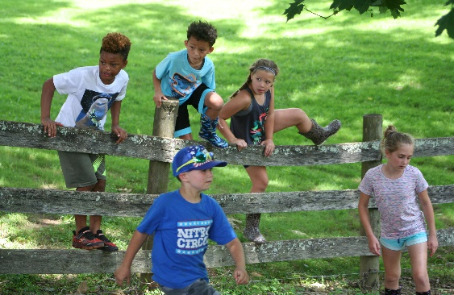

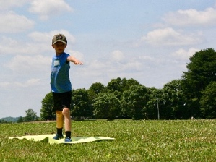
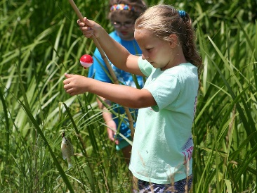

June 21-24
ages 7-12
9:00-3:00 (drop off 8:30/pick up 4:00)
$340.00
2022 Local Farm Experience for Kids!!
Farming Me …sowing the soul is offering a 4-day farm experience for children of various ages. Our goal is to unplug, have outdoor fun, and get back to basics. We have built a community of teachers and local artists who share in the Farming Me vision and will participate daily. We have planned many farm adventures along with two artist sessions daily to expose children to nature and mindful practices on the farm. Come play and experience nature at its finest!!
Register: Farmingme.com
Email: Farmingme3@gmail.com
COMPLETE:
Registration form and Liability Waiver
PAY: check, cash or Venmo
Check made payable to:
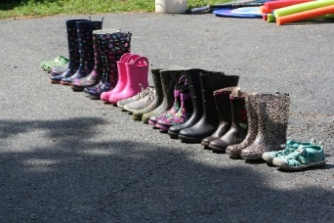
Farming Me
2239 Price Road
Darlington, MD 21034
Venmo-Raine Archer

